Design Patterns. Own framework. HW.

Directory src/framework

Pattern Facade (./core/module.js)

The facade is a simple interface for working with a complex subsystem containing many classes. In fact, class Module hides a complex (well, or not very complex) implementation of rendering components.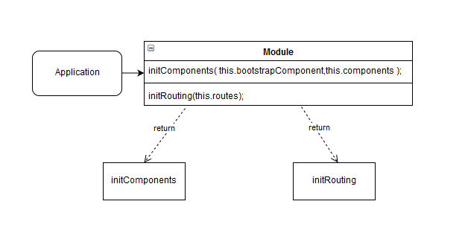

Pattern Singleton (./core/routing/init-routing)

A singleton is a generative design pattern that ensures that the class has only one instance and provides a global access point to it. Router is an ideal example of a singleton. 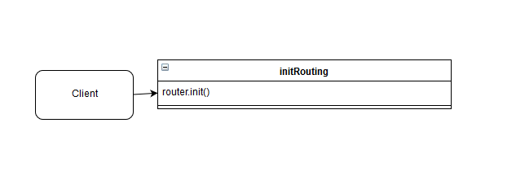

Pattern Iterator (./core/component/init-components)

An iterator is a behavioral design pattern that makes it possible to consistently bypass the elements of composite objects without revealing their internal representation. The method takes an unchanged part of the page layout and the main components

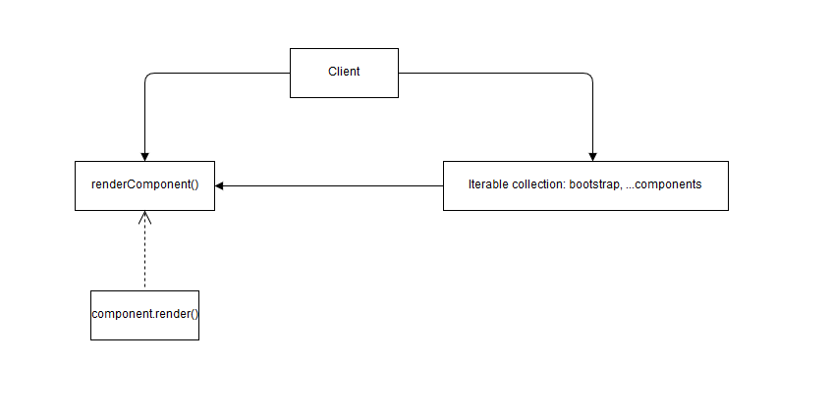

Pattern Decorator (./core/component/component)

The decorator is a structural design pattern that allows you to dynamically add new functionality to objects, wrapping them in useful "wrappers".

